**Schematic Reading Notes:**

You’ll encounter three types of diagrams in electricity and electronics: block, schematic, and pictorial.

A block diagram gives you an overview of how the discrete circuits within a device or system interact.

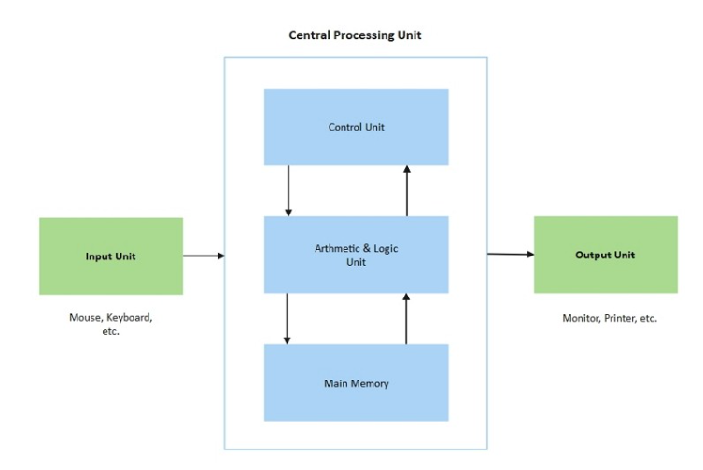

Schematic diagram: a simplified drawing showing how components are connected in a system, using symbols and lines to help design, build, and troubleshoot.

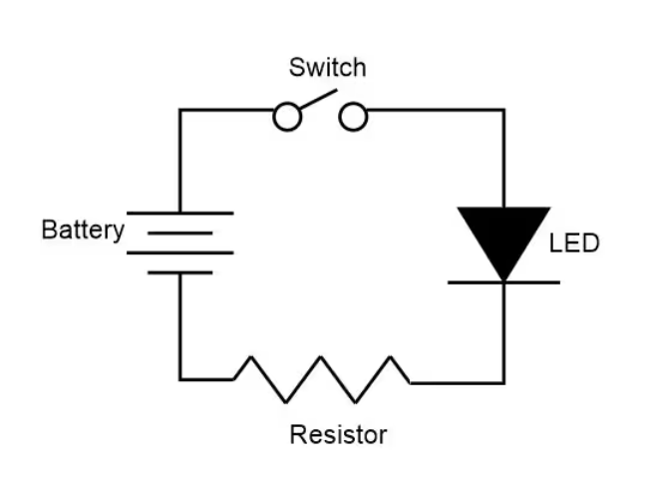

A pictorial diagram, sometimes called a layout diagram, shows the actual physical arrangement of the circuit elements on the circuit board or chassis, so that you can quickly find and identify components to test or replace.

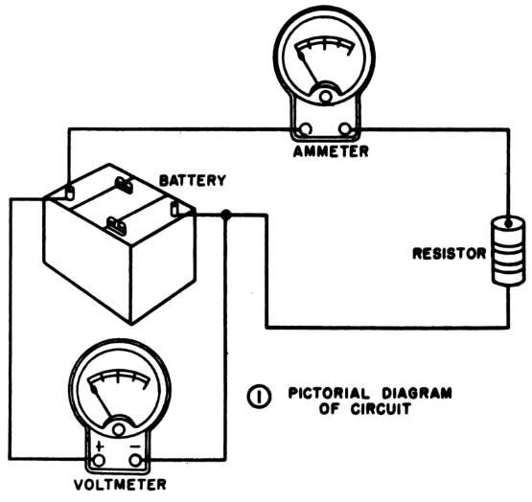

When you troubleshoot an unfamiliar electronic circuit, you’ll usually start with the block diagram to find where the trouble originates. Then you’ll refer to the schematic diagram (or part of it) to find the faulty component in relation to other components in the circuit. A pictorial diagram can then tell you where the faulty component physically resides, so that you can test it and, if necessary, replace it.

In a block diagram, each block represents all of the schematic symbols related to that part of the circuit. In addition, each block has a label that describes or names the circuit it represents. However, the block does nothing to explain the actual makeup of the circuit it represents.

A block diagram can provide a clear understanding of how each part operates in conjunction with the others.

A schematic diagram acts, in effect, as a map of an electronic circuit, showing all of the individual components and how they interconnect with one another.

A schematic drawing must indicate not only all components necessary to make a specific scheme, but also how these components interrelate to one another.

A schematic diagram reveals the scheme of a system by means of symbology. Symbology in schematic diagrams refers to the use of standardized symbols, icons, and graphics to represent components, devices, and concepts in a clear, consistent, and efficient visual representation of a system or process.

Inconsistencies arise in schematic symbology, and that’s a situation that makes electronics-related diagrams more sophisticated than road maps.

By knowing the type of component alone, you can’t tell what role it plays in a circuit until you have a good schematic diagram showing all the components in the circuit, and how they all interconnect. Rarely can you get all this information in an easy-to-read format by examining the physical hardware.

Hard-wiring: the physical components and interconnections of a circuit.

A schematic diagram gives you an overall picture of a circuit and shows you how the various routes and components interact with other routes and components. When you can see how the overall circuit depends on each individual circuit leg and component, you can diagnose and repair the problem.

Our senses along with our central processor, the brain, render us less than proficient at mentally conceiving all of the workings of electronic circuits by dealing with them directly. Therefore, we have to accept data a small step at a time, compiling it in hardcopy form (through symbology) and providing hardcopy readout.

Schematic symbols and diagrams are designed for human beings, so human logic constitutes a prime factor in determining which symbols mean what.

Schematic diagrams are encoded representations of circuits, while pictorials show us the physical objects, often proportioned according to their relative size, and sometimes rendered so as to look three-dimensional by means of shading and perspective. Schematic diagrams depict circuit components as symbols only, without regard to their real-world size or shape, and in two dimensions, completely lacking depth or perspective.

A block diagram portrays the general construction of an electronic device or system. A block diagram can also provide a simplified version of a circuit by separating the main parts and showing you how they are interconnected.

In sequence going from left to right, the electricity passes through the transformer, the rectifier, and the filter before arriving at the output as DC. In this case, the lines that connect the blocks do not have arrows because readers will naturally assume that the flow goes from left to right. In more complicated block diagrams, the interconnecting lines may include arrows to show which block affects which, or to indicate the general direction of signal flow when it might not otherwise be clear.

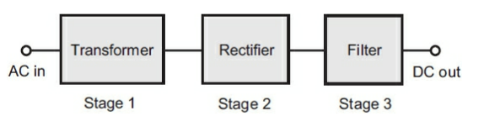

Block diagrams can also be called functional diagrams because they reveal the basic functioning of the electronic circuit.

Block diagrams may constitute the beginning design for a circuit. The next step would be to develop it into a schematic diagram by putting in the circuits that fill in each block.

A schematic diagram may mark the beginning of a circuit design. Sometimes, you have the detail without knowing the overall flow of the design, so someone would have to work backward to come up with the block diagram demonstrating how operation happens.

If presented without accompanying schematics, a block diagram describes the basic functional operation of an electronic device or system. The block diagram can prove most useful when you don’t need to know the functions of individual components.

When we need to know, or portray, individual differences between circuits that do essentially the same things, then we need schematic diagrams.

In the below block diagram, the flow of electricity is shown using arrows. They also usually tell the user the sequence of events or direction of signal flow.

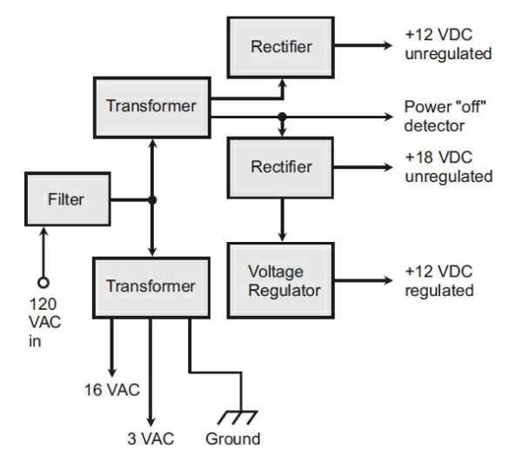

More sophisticated block diagrams also include triangles to represent circuit blocks built around specialized amplifiers constructed within integrated circuits (ICs), also known as chips.

Block diagrams can describe the functioning of electronic circuits, but in the world of computers, another form of diagramming is sometimes used to portray the functioning of a program. This system is a flowchart. A flowchart provides a graphic representation of the logical paths that a computer will take as it executes a particular program.

For complex problems, a formal written specification might be necessary to ensure that everyone involved understands and agrees on what the problem is, and on what the results of the program should be.

When the flow of control is complicated by many different paths that result from many decisions, a good flowchart can help the programmer sort things out. The flowchart can serve as a thinking-out tool to understand the problem and to aid in program design.

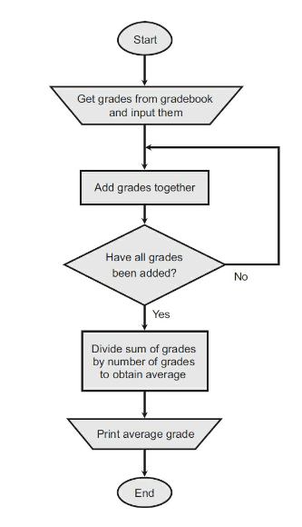

In order to promote uniformity in flowcharts, standard symbols have been adopted.

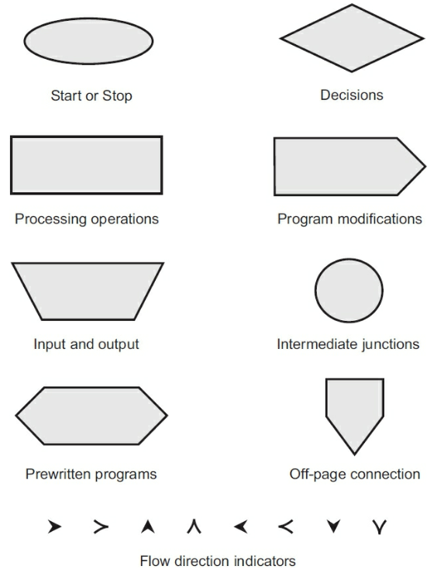

The normal direction of processes in a flowchart runs from top to bottom and from left to right, the same way as people read books in most of the world. Arrowheads on flow lines indicate direction. The arrows can be omitted if, but only if the direction of flow is obvious without them.

A small five-sided box, which has the shape of the home plate on a baseball field, shows where one page of a flowchart connects to the next, if the entire flowchart has more than one page. The intermediate junction and off-page connection points are labeled with numbers and letters to let readers know that all like symbols with the same character inside are meant to be connected together.

From a purely electronic standpoint, functional diagrams abound and are usually more numerous than the schematic diagrams in the computer world.

With schematic drawings, symbols indicate conductors, resistors, capacitors, solid-state components, and other electronic parts. Every time a new component comes out, a new schematic symbol is derived for it. Often, a new type of component is a modification of one that already exists, so the new schematic symbol ends up as a modification of the symbol for the preexisting component.

Resistors are among the simplest electronic components. As the term implies, they resist the flow of electrical current. The common symbol for a resistor is shown below.



The symbol below demonstrates an adaptation of a common symbol when a component is a variation of another. This symbol is for a two-terminal variable resistor. The arrow across means that this component can be adjusted upward.

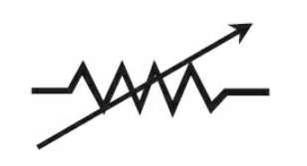

The symbol below is for a resistor that connects one end to the tap.

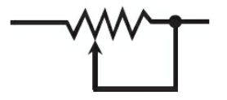

The symbol below is a resistor that uses a three-terminal arrangement.

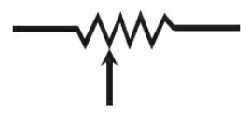

In schematic drawings, an arrow *often* indicates variable properties of a component, but not always! Transistors, diodes, and some other solid-state devices have arrows in their schematic symbols. These arrows don’t have anything to do with variable or adjustable properties. Arrows can also sometimes indicate the direction of current or signal flow in complex circuits.

The below symbol represents a variation of a typical resistor called a rotary potentiometer.

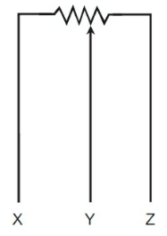

Capacitors are electronic components that have the ability to block direct current (DC), while passing alternating current (AC). The standard symbol for a capacitor is shown below.

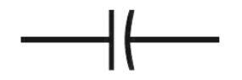

Much like what has been shown for variations on resistors, the same can be said of capacitors. Below is the symbol for an air dielectric capacitor.



And this is the symbol for a solid dielectric capacitor.

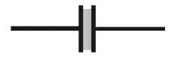

Horizontal lines connect to the centers of the vertical line and the parenthesis to indicate the component leads. The parenthesis side of a capacitor indicates the lead that should go to electrical ground, or to the circuit point more nearly connected to electrical ground.

Below is the schematic symbol for a polarized or electrolytic capacitor. This symbol is the same as the one for the nonpolarized component, but a plus (+) sign has been added to one side. This sign indicates that the positive terminal of the component goes to the external circuitry. Occasionally, a negative (–) symbol will also appear on the opposite side.

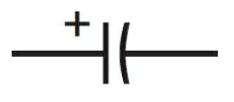

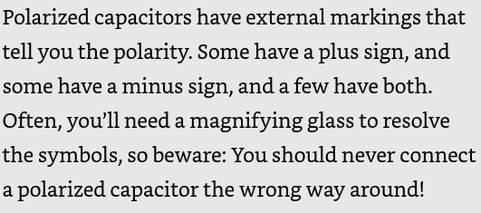

Arrowed lines that run diagonally across a symbol usually denotes variability (the ability to change capacitance value).

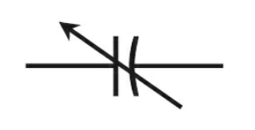

The other two ways that you may see a variable capacitor are shown below. Note: the above symbol is considered the standard. Probably the best takeaway is that there will be some kind of arrow notation.

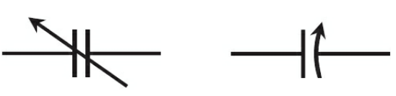

Sometimes, two separate variable capacitors are connected together or ganged in a circuit. In a ganged arrangement, two or more units are used to control two or more electronic circuits, but both components are varied simultaneously by tying the rotors of the two units together.

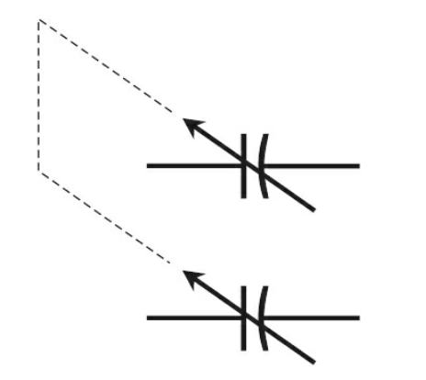

An air-core inductor is a type of inductor that uses air as its core material, rather than a magnetic material like iron or ferrite. This means that it doesn't use a magnetic core to increase its inductance, but instead relies on the air surrounding the coil to store energy. The symbol for this component is shown below.



A tapped arrangement allows for the selection of an input or output point that offers lower inductance than the full coil does.

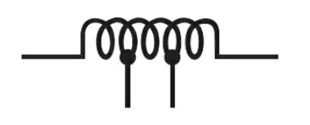

Much like a variable capacitor, a variable inductor is indicated by an arrow going through it. Either one of the two bottom symbols can be used to indicate this.

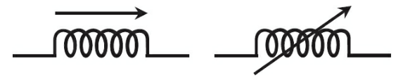

When an iron core is added to an inductor, it becomes stronger. Both symbols below are what you may see with a solid or laminated iron core inductor. Look for the two bars to recognize this component.

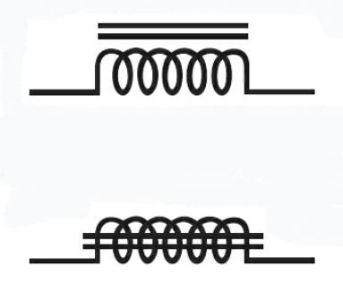

A tapped coil inductor with a solid or laminated core will have the two bottom prongs like a tapped inductor, while an arrow going through will mean the component is a variable solid or laminated core inductor like a regular variable inductor symbol.

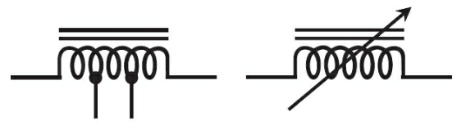

At higher frequencies, solid-iron and laminated-iron cores aren’t efficient enough to function in inductors. Engineers would say that they have too much loss. A special core is needed if you want to increase the inductance over what you can get with nonferromagnetic core materials, such as air, plastic, ceramic, or wood. A physically- solid sample called a powdered-iron core is often used. The symbols below demonstrate how this looks: almost identical to a solid or laminated core, but with broken up lines. These types of components, like all other types of inductors, can be tapped or continuously variable.

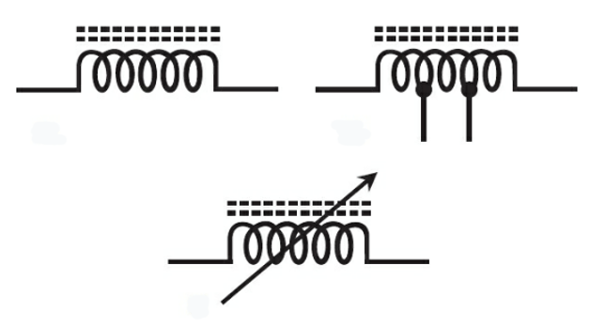

A transformer is made up of multiple inductors with the coil turns interspersed or wound around different parts of a single core.

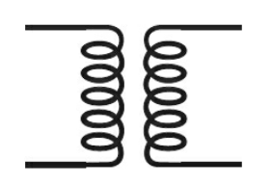

These can also come with iron cores:

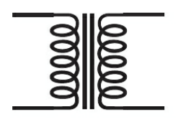

Cores and taps:

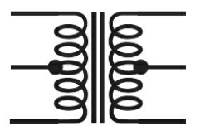

With a powdered-iron core:

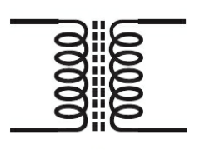

And as an adjustable, with powdered-iron core:

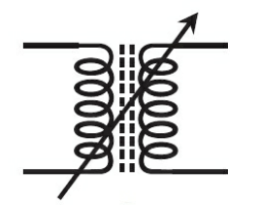

A switch is a device, mechanical or electrical, that completes or breaks the path of current. Additionally, a switch can be used to allow current to pass through different circuit elements. A single-pole/single-throw (SPST) switch is shown below. It is a two-position device because it is either on or off.

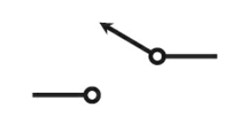

A different type of switch, called a single-pole/double-throw (SPDT) component is shown below. Symbolically, the pole coincides with the point of contact at the base of the arrowed line.

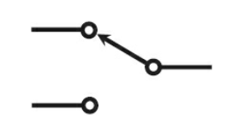

Some switches can have more than one poles or throws. The figure below shows the symbol for a double-pole/single-throw (DPST) switch, and the other shows the symbol for a double-pole/double-throw (DPDT) switch.

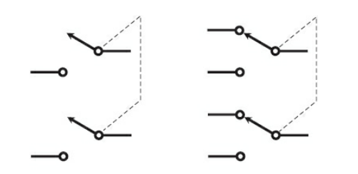

These two switches can actually be covered under the heading of multi-contact switches.

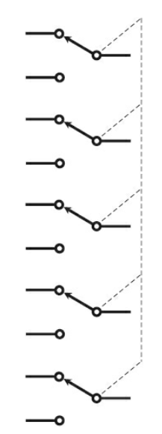 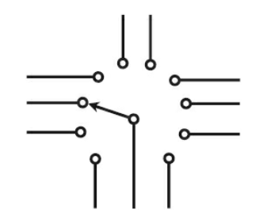

The arrangement below is interesting because it shows two ganged rotary switches. In this depiction, the arrowed line indicates where these two switches are in synch.

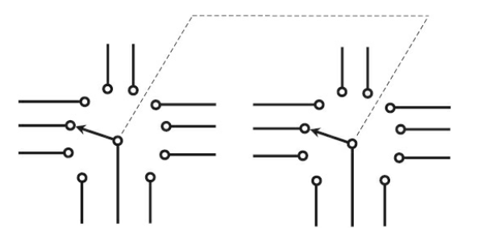

Some amateur radio operators use a special switch called a Morse code key. This old-fashioned device, also called a hand key or a straight key, makes or breaks a circuit for the purpose of sending Morse code manually. It’s an SPST (single pole, single throw) switch with a lever and a spring, causing the device to return to the off position when the operator lets go of the lever.

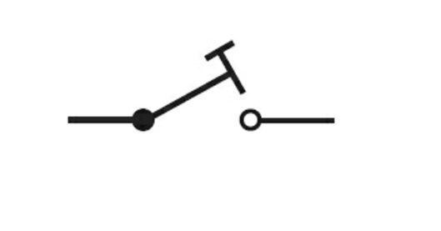

In the following schematic drawing, you have to draw one conductor across another to reach various circuit points without introducing a whole lot of confusion and clutter, or resorting to three dimensions to make your drawing. Despite how this looks, these conductors are *not* electrically connected.

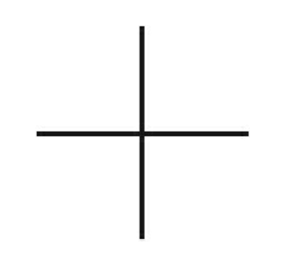

Because the above diagramming can be confusing, there are a few alternatives. In the below diagram, the two conductors have dots drawn where they intersect, indicating that they *are* electrically connected. As long at the schematic is printed large, the reader will be able to see that detail.

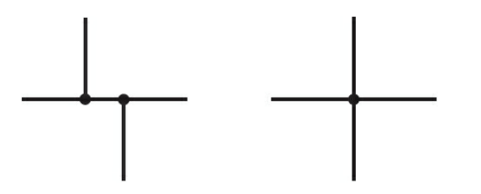

Yet another alternative is to diagram intersecting conductors with an arc- indicating that they cross but have no physical connection otherwise. While this is generally much easier to interpret it is, sadly, deprecated and usually only found in older schematics.

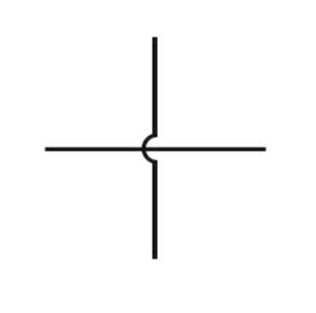

A cable consists of two or more conductors inside a single insulating jacket. In many cases, unshielded cables are not specifically indicated in a schematic drawing, but appear as two or more lines that run parallel to indicate multiple conductors. Shielded cable is interpreted as a single, continuous, line surrounded by two shorter lines- indicating the insulating layer.

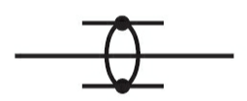

When an insulated cable is grounded, this is indicated by three short lines connected to the cable by another long line. Sort of like an anchor.

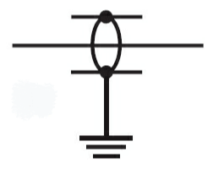

In the below diagram, the cable is grounded to a chassis. This is depicted in a way that the three lines are shown flattened out- mimicking a 3-dimensional surface.

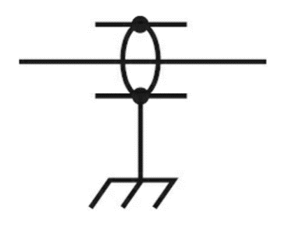

Finally, two long and continuous lines in the center indicate cabling with two conductors passing through and also grounded to a chassis of some sort.

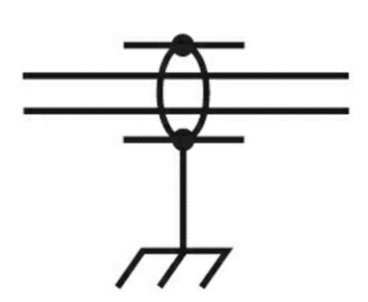

The symbol below shows a rectifier diode. The part to the left, concluding at the arrow tip, is called the diode’s anode. The short line at the arrow’s tip, vertically oriented, is called the diode’s cathode.

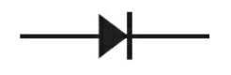

Below are examples (left to right) of a varactor diode, Zener diode, and Gunn diode. Note how there is always an arrow that intersects with something at the middle. This is the key to remembering this type of element.

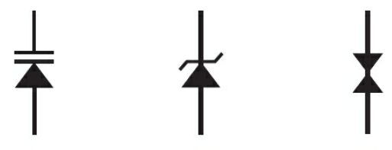

The diode shown below is another variation, called a silicon-controlled rectifier (SCR). SCRs usually- but not always- show a circle around the intersection point of the diode (also called a gate).

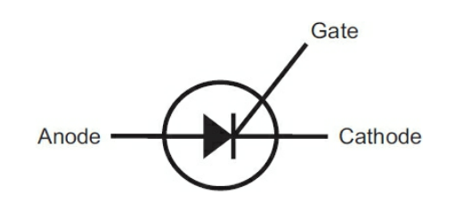

The symbol below shows two bipolar transistors. The difference between them is due to the arrow direction. In the PNP device, the arrow points into the straight line for the base electrode. In the NPN device, the arrow points outward from the base. Occasionally, the circle that surrounds the base, emitter, and collector leads is omitted from the bipolar transistor symbol.

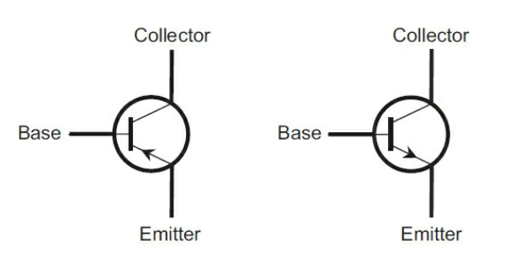

These are some other variations on a transistor. Notice that they all show some kind of gate in the middle that shows to the left of the conductor.

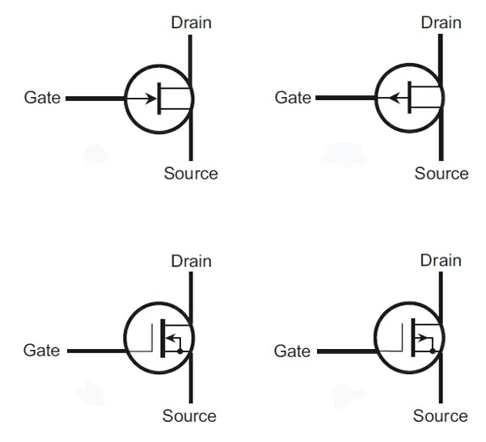

A filament is a thin, thread-like structure found in various contexts. In light bulbs, it refers to a thin wire that emits light when heated.

When you want to create the symbol for a vacuum tube, you should start by drawing a fairly large circle, and then you should add the necessary symbols inside the circle to symbolize the type of tube involved.

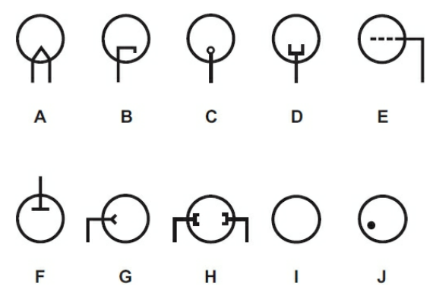

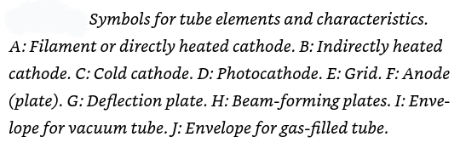

Below is the symbol for a diode vacuum tube. Note that it contains both an anode (also called a plate) and a cathode. This element has a filament, but it is typical that it is not shown in diagrams where the cathode and filament are not physically connected (a situation called an indirectly heated cathode.)

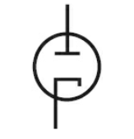

All tube elements are surrounded by a circle, which represents the tube envelope. Occasionally, the circle is omitted from some tube symbols in schematic drawings, but that’s not standard practice.

The next image shows two versions of a triode vacuum tube, which consists of the same elements as the diode previously discussed, with the addition of a dashed line to indicate the grid. One has a directly heated cathode and the other has an indirectly heated cathode.

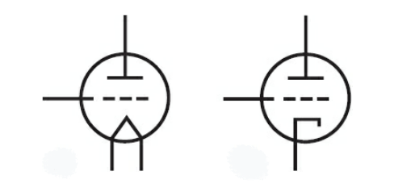

In schematics, a grid is a set of intersecting horizontal and vertical lines that create a reference framework for drawing and organizing electronic components and their connections. This grid helps designers and engineers accurately place and align components such as resistors, capacitors, and integrated circuits. It also aids in ensuring clear and systematic representation, making it easier to read and understand the circuit's design and layout.

Tetrode vacuum tubes have two grids. To represent one of them, we need an additional dashed line. the upper grid, closer to the anode, is called the screen. The below example is a directly heated cathode.

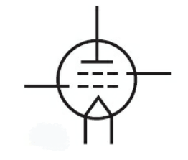

Below is a pentode tube, which has three grids and a total of five elements. In the pentode, the second grid (going from the bottom up) is the screen, and the third grid (just underneath the plate) is called the suppressor. The left side shows a directly heated cathode pentode tube. The right is an indirectly heated cathode pentode tube.

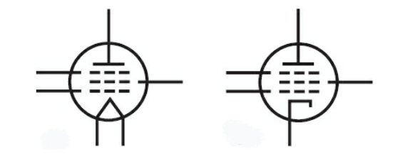

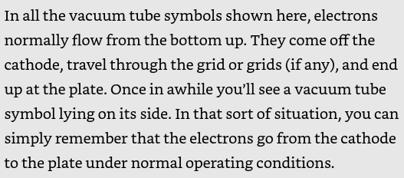

Dual tubes: vacuum tubes consist of two separate, independent sets of electrodes housed in a single envelope. If the two sets of electrodes are the same, these tubes may be called a dual diode, dual triode, dual tetrode, or dual pentode.

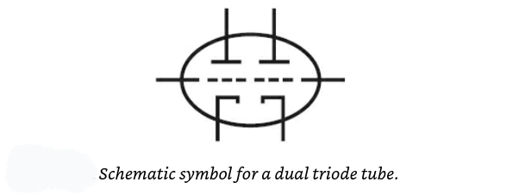

Hexode tubes have six elements.

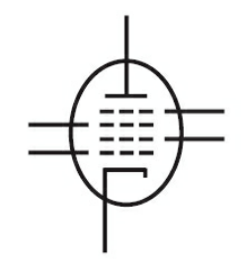

Heptode tubes- also called pentagrid converters- have seven elements.

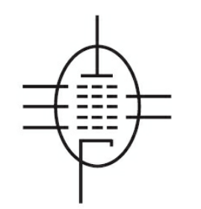

A cell or battery is often used as a power source for electronic circuits. Electrochemical batteries with higher voltage outputs comprise multiple cells connected in series (negative-to-positive in a chain or string); the schematic representation for a multicell battery takes this design into account.

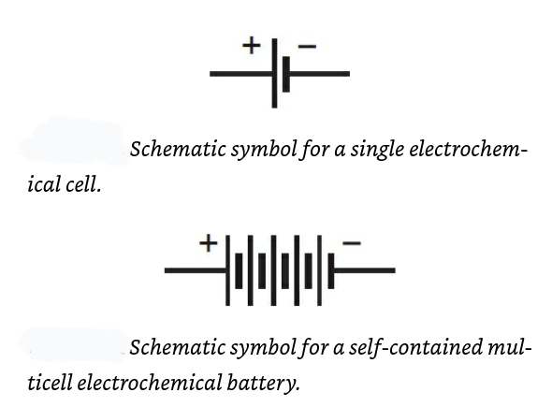

If a circuit calls for the use of three individual, discrete single-cell batteries in a series connection, you might draw three cell symbols in series with wire conductor symbols between them.

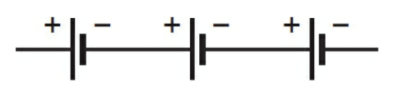

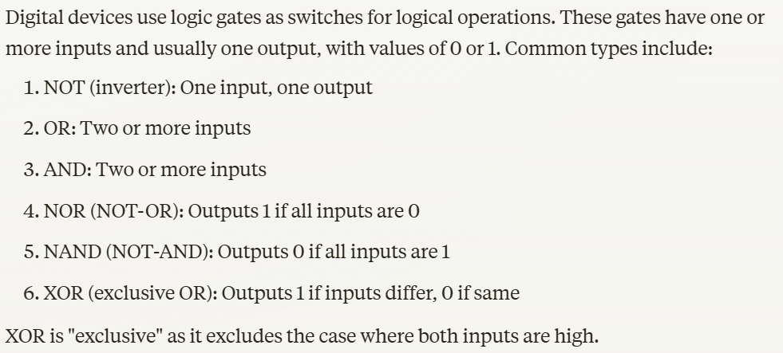

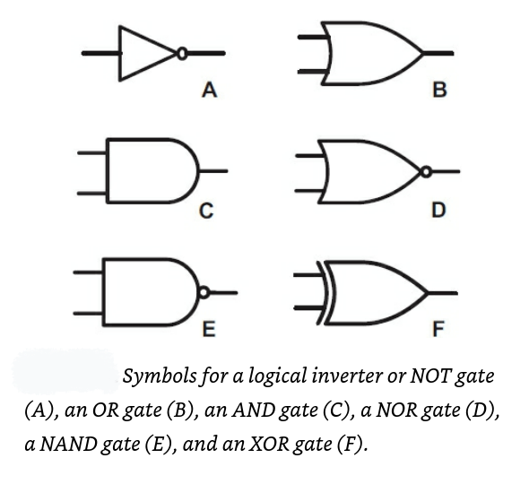

Note: the following graphics were added because the text these notes were pulled from excluded some electronic symbols.

General Circuit Symbols

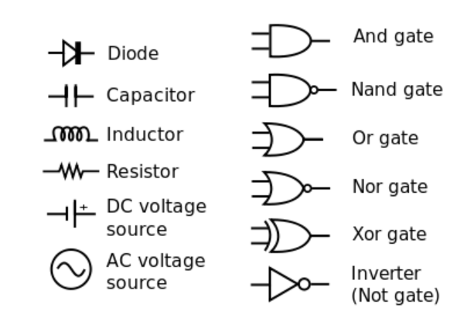

Wire Symbols

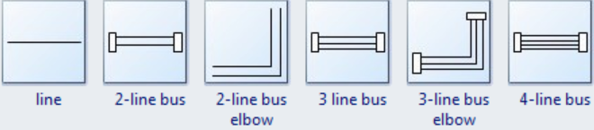

Switch Symbols

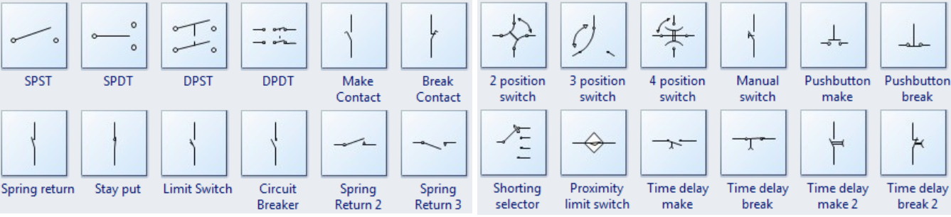

Power Source Symbols

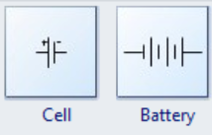

Ground Symbols

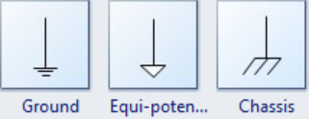

Resistor Symbols

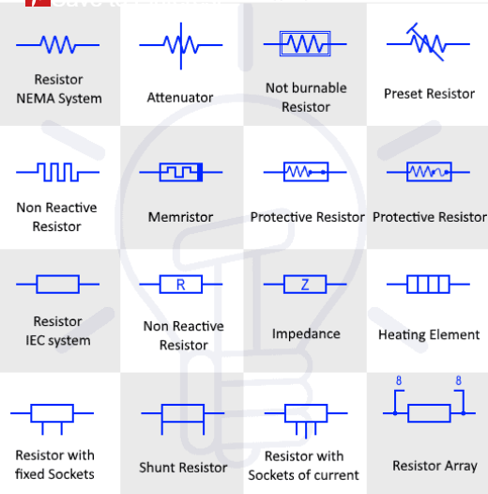

Capacitor & Condenser Symbols

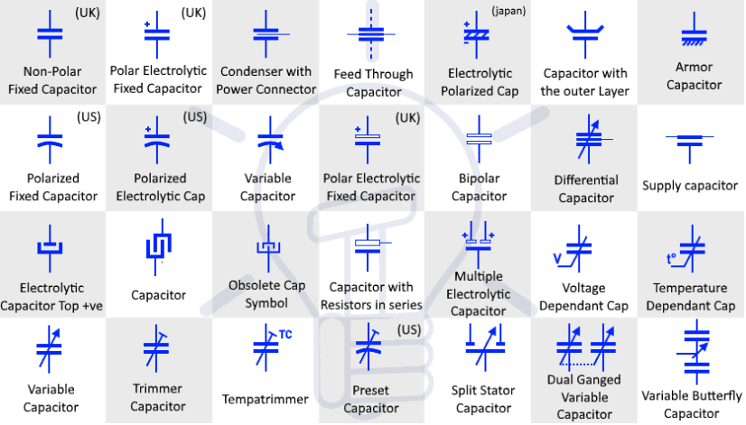

Inductor Symbols

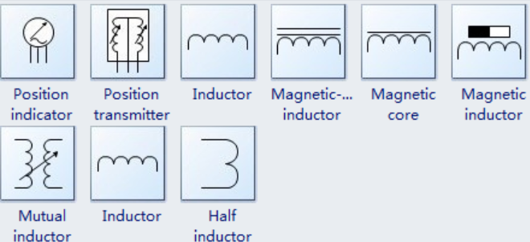

Diode Symbols

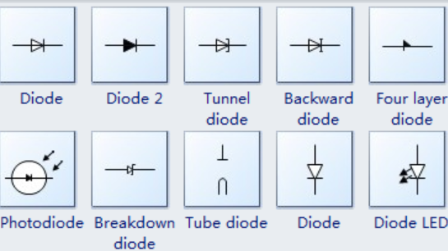

Transistor Symbols

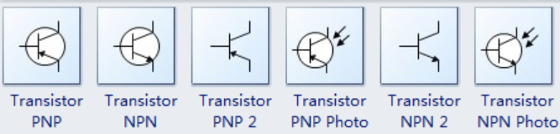

Logic Gate Symbols

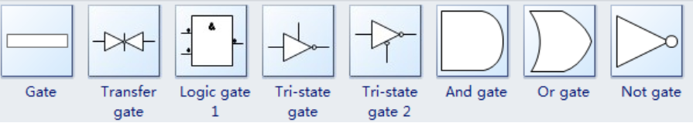

Amplifier Symbols

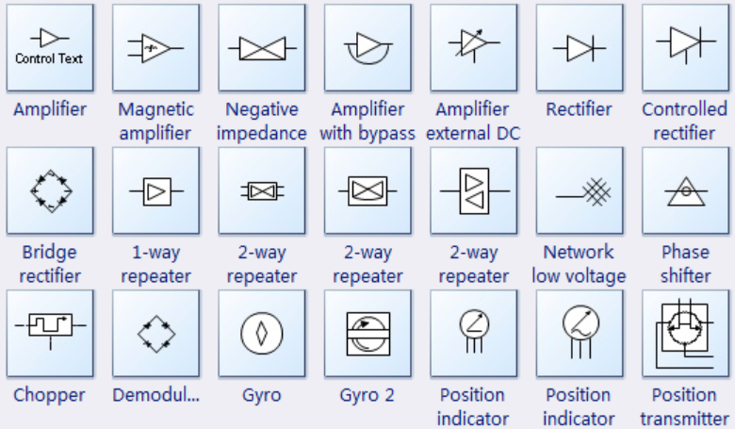

Antenna Symbols

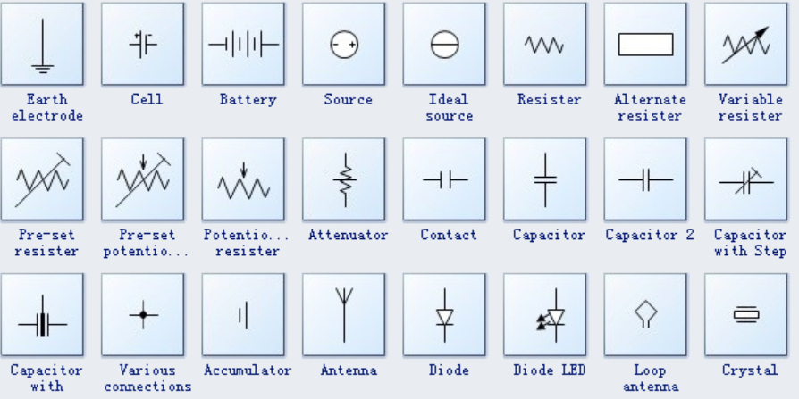

Transformer Symbols

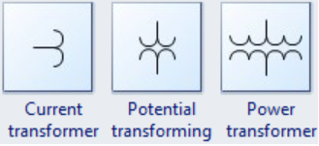

Ammeter and Voltmeter Symbols

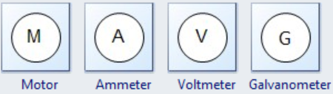

Connection Symbols

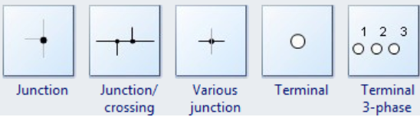

Source Symbols

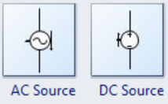

Fuse Symbols

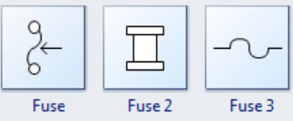

Lamp Symbols

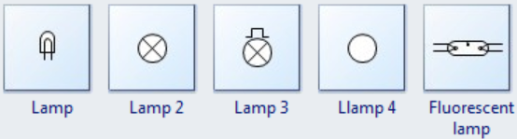

Bell & Buzzer Symbols

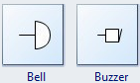

Inductor Symbols

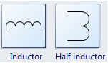

Relay Symbols

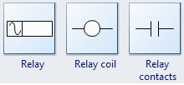

Phase Symbols

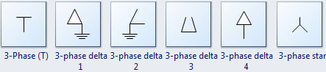

Semiconductor Symbols

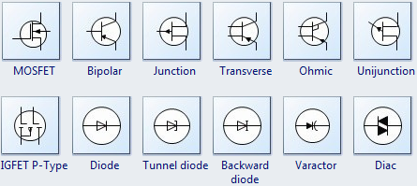

Speaker & Microphone Symbols

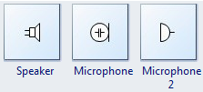

Conductor Symbols

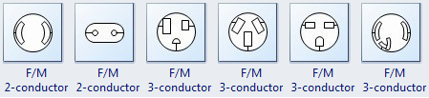

Integrated Circuit Symbols

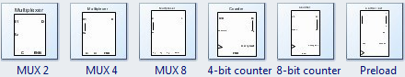

Digital Circuit Symbols

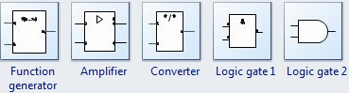

In most instances, a circuit is designed schematically first, and then built and tested from the schematic.

The pictorial illustration below shows a simple circuit that everyone has used at one time or another. It’s a flashlight with the external case and the on/off switch removed.

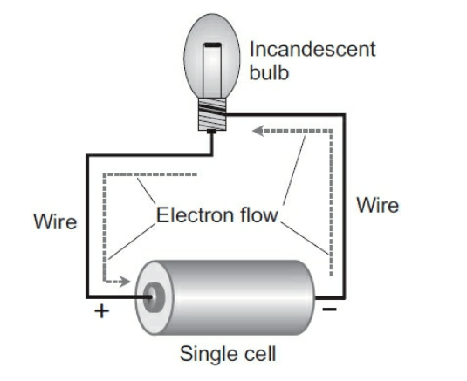

Electrons travel from the negative terminal of the cell through the bulb element and back to the positive terminal of the cell, “leapfrogging” from atom to atom in the metal wire and the bulb filament. That’s how most electricians and engineers look at this situation. But some physicists will tell you that the current actually goes from the positive cell pole to the negative cell pole. That’s called theoretical current or conventional current.

Three elements of that schematic diagram must be known to read it properly: the electrochemical cell, the bulb, and the conductors-

Electrochemical cell:

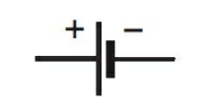

Conductor (or wire):



Incandescent Bulb:

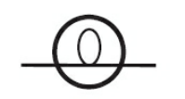

Here is what these symbols look like, representing the flashlight from the diagram above, as a schematic.

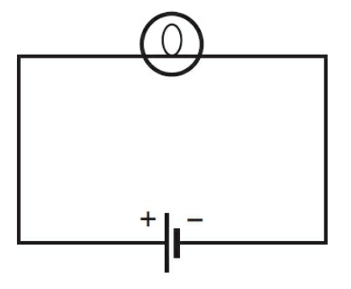

A more complicated version can feature a switch and an additional cell.

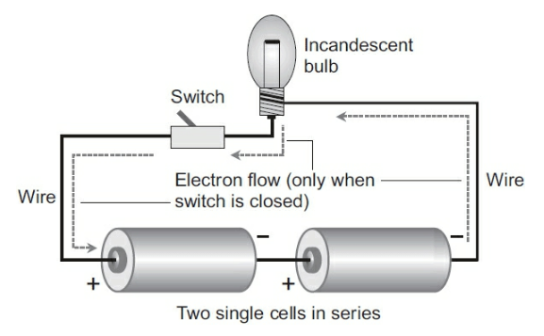

Before that can be shown as a diagram, we need to become familiar with the switch symbol.

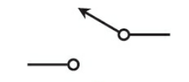

Now, this is an updated schematic with the switch and second cell shown.

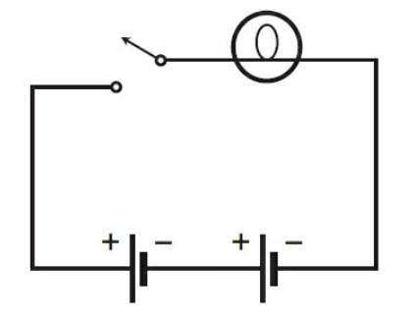

Another basic circuit example is a field-strength meter.

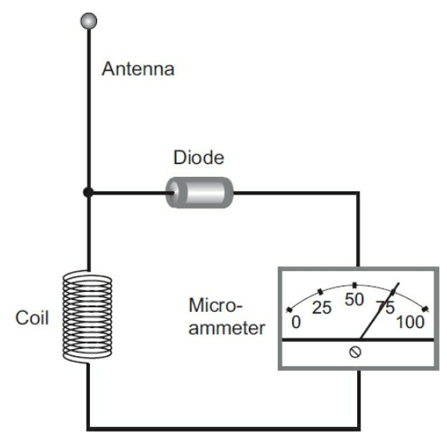

For this, we need to know some new symbols.

Antenna:

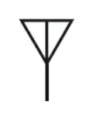

Microammeter:

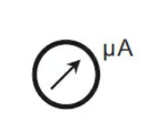

Now, we can build a schematic of the field-strength meter by also using a coil symbol and a diode symbol.

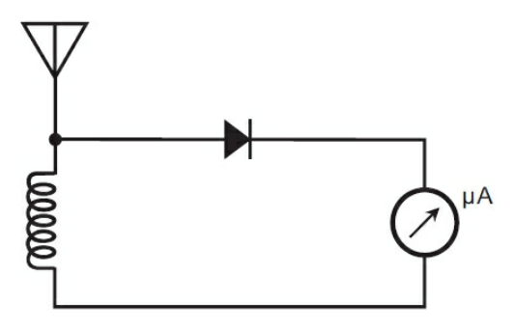

And below is a slightly more complicated schematic for a simple DC power supply. New symbols can be seen for a fuse and plug on the left of the diagram.

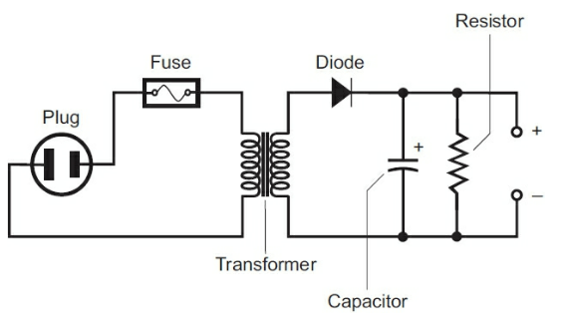

Ripple in electrical circuits refers to the residual periodic variation of the direct current (DC) output voltage within power supplies, typically resulting from incomplete suppression of the alternating current (AC) waveform after rectification. This ripple appears as a small, fluctuating voltage superimposed on the steady DC output.

When bleed occurs between a resistor and a capacitor, it typically refers to a small, unintended current that flows through the resistor, slowly discharging the capacitor over time. This bleed current can affect the timing and performance of circuits that rely on precise charge and discharge cycles, such as in RC (resistor-capacitor) timing circuits.

The letters that identify each component are more or less standard. Notice that each letter is followed by the number 1. The designation T1, for instance, indicates that the component is a transformer (T) and that it’s the first such component referenced. If this circuit had two transformers, then one of them would bear the label T1 and the other one would bear the label T2.

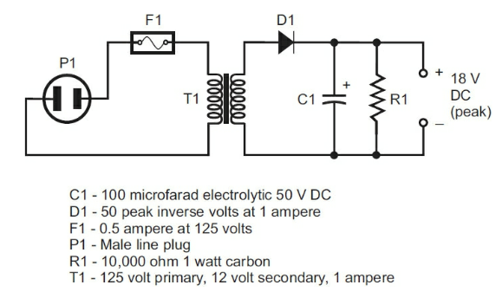

In the previous schematic, you don’t necessarily have to include a number next to each component designation because only one of each component is used to make up the entire schematic.

Standard diagramming practice requires that you always include a letter and a number, even if only one of a certain component type exists in the whole circuit.

In complicated electronic systems, several hundred components of the same type (resistors, for example) might exist, many of which come from the same family. For instance, if you see the designation R101, then you know that the system contains at least 101 resistors. If you want to know the type and value of resistor R101, you will have to look up R101 in the components list to find its specifications.

If the component has a complex name, such as silicon-controlled rectifier, the first letters from each of the three words is used, so you get SCR1.

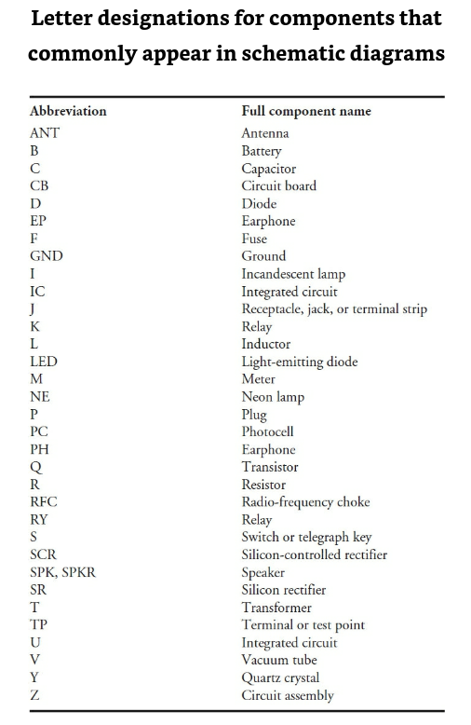

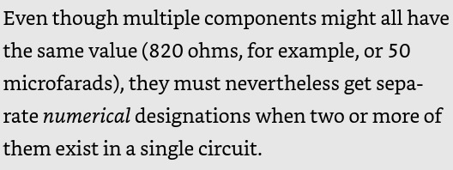

A "foil run" refers to the conductive paths made from a thin layer of metal, typically copper, on a printed circuit board (PCB). These conductive paths are also known as "traces" or "tracks."

Connections might be made with wires attached to the resistor leads, but if the components are close together, the leads themselves can form the interconnections.

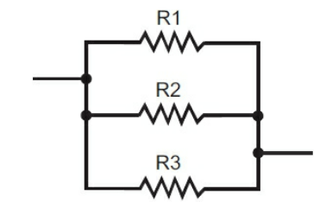

You also need to know what tasks the various components actually perform, as well as how the diverse circuits work together in a complete system.

The schematic diagram allows a technician to make educated guesses as to where or what the trouble might be, but an exhaustive diagnosis will nearly always require testing. A particular malfunction in an electronic device will not necessarily have a single, easy-to-identify cause. Often there are many possible causes, and the technician must whittle the situation down to a single cause by following a process of elimination.

Test point (TP): a specific location in an electronic circuit where measurements can be taken to diagnose and troubleshoot issues. These points are typically designed to be easily accessible and provide a reliable location for connecting test equipment like multimeters, oscilloscopes, and logic analyzers.

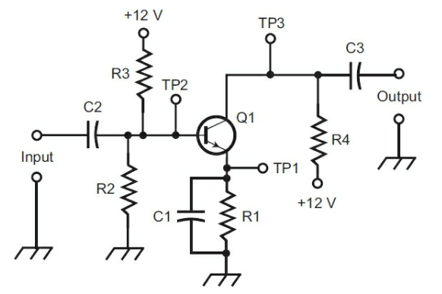

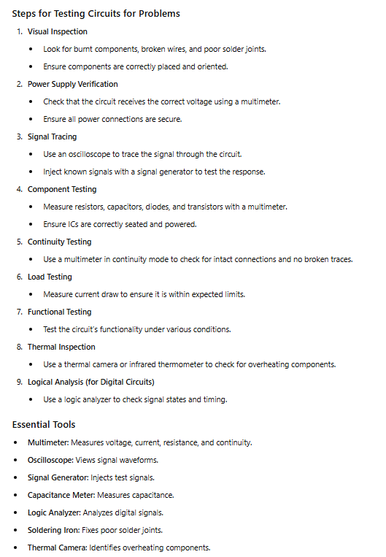

In many electronic circuits, actual voltages can deviate from design values by up to 20 percent; if this information is important, you’ll usually find the error range at the bottom of the schematic drawing or in the accompanying literature. If the readings obtained are within this known error range (called the component tolerance), then you can tentatively assume that this part of the circuit is working properly. However, if the readings obtained are zero or well outside of the tolerance range, then you have pretty good reason to suspect a problem with the associated circuit portion, or possibly with other circuits that feed it.

A few alternative labeling forms are also acceptable. In the following schematic, the parts list has been eliminated and the diagram contains no alphabetic/numeric designations. Instead, the components are identified only by their schematic symbols along with value designations or industry standard part designations.

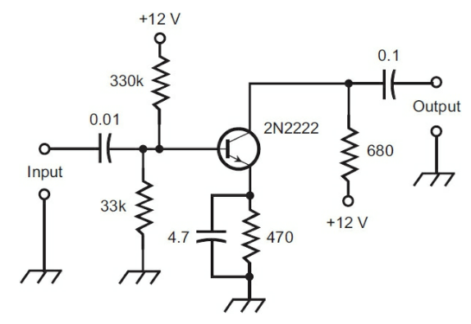

With schematics like the one above, you’ll usually see a statement at the bottom of a schematic diagram that includes information about the units for the value designations. Such a statement might read “All capacitors are rated in microfarads (μF). All resistances are given in ohms (Ω), where k = 1000 and M = 1,000,000.”

Once in a while, you’ll encounter a “hybrid” drawing that consists of a block diagram and a schematic diagram combined. This diagram serves two purposes. First, as you read the schematic portion, you can study the actual component makeup of the buffer circuit. Second, you get a good idea as to the buffer’s place in the overall system relative to the other circuits.

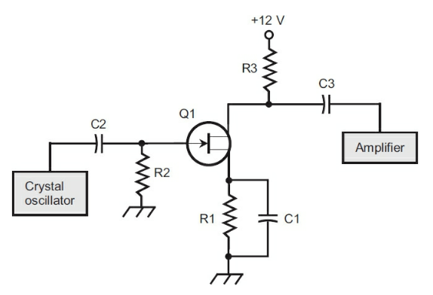

A hybrid diagram in schematics combines different types of visual representations, such as circuit diagrams and block diagrams, into one unified view. This approach provides a comprehensive understanding of both detailed components and the overall system.

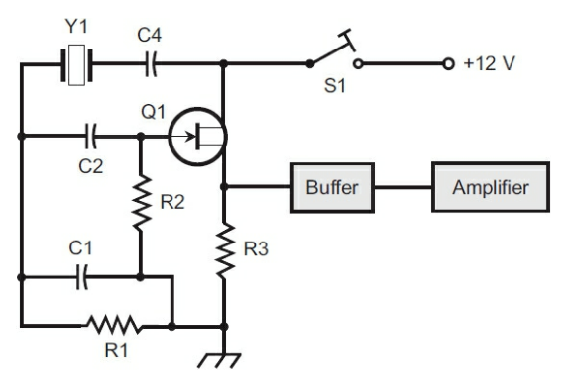

Sometimes, a diagram will combine a block diagram with a schematic diagram so that the reader can see how the two relate to one another.

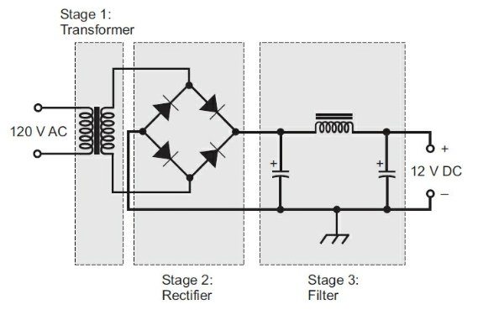

For complex circuits, even an amateur may be able to understand by examining each building block at a time. Each building block represents a simple circuit.

An integrated circuit (IC) is a small semiconductor chip that houses multiple electronic components like transistors and resistors, all connected to perform specific functions. ICs are essential in modern electronics, enabling the miniaturization and mass production of devices such as computers, smartphones, and medical equipment. These come in small “packages” that can be thought of as building blocks.

In reading schematics with integrated circuits, it will contain rectangles representing the chips, along with a great many lines connecting them. In most real-world circuits, those lines represent foil runs on a printed circuit board.

In electronics, a crystal refers to a small piece of quartz or similar material that vibrates at a precise frequency when an electric current passes through it. This vibration helps maintain accurate timing in electronic circuits, making crystals essential for clocks, radios, and other devices that rely on precise timing signals.

A demodulator is an electronic component that extracts the original information (like audio or data) from a modulated carrier signal, which is often used in communication systems. For example, in a radio, the demodulator separates the music or voice from the radio signal, allowing you to hear it clearly.

A "cat's whisker" in electronics refers to a thin wire used in early crystal radios to make contact with a crystal (usually galena) to detect radio signals. The wire had to be carefully positioned to find the right spot on the crystal where the signal was strongest, allowing the radio to pick up and demodulate radio broadcasts. It was one of the first types of detectors used in radio technology.

An amplifier in electronics is a device that increases the strength of a signal, such as sound, radio waves, or voltage. It takes a weak input signal and produces a stronger output signal without changing the original signal's content. Amplifiers are commonly used in audio systems, radios, and other devices to make sounds louder or to boost signals for transmission.

In electronics, amplitude is the measure of a signal's strength or magnitude. It indicates how much the signal varies from its average value, with higher amplitude meaning a stronger signal.

A resonant frequency is the specific frequency at which a system naturally oscillates with the greatest amplitude. When an external force or signal matches this frequency, the system resonates, producing a stronger response. This concept is used in various applications, such as tuning radios to a specific station or designing circuits with certain frequencies for filters and oscillators.

A preamplifier is a device that boosts a weak signal to a higher level before it is sent to a main amplifier. It helps improve the signal quality and reduce noise, making it easier for the main amplifier to process and amplify the signal effectively.

An *audio* power amplifier is a device that increases the power of an *audio* signal to drive speakers or other audio output devices. It takes a low-level audio signal and amplifies it to a level sufficient to produce sound at a higher volume.

A push/pull circuit is a type of amplifier design that uses two transistors or other components to amplify a signal. One component handles the positive part of the signal, while the other handles the negative part. This setup improves efficiency and reduces distortion, making it ideal for amplifying audio and other signals.

In order to work properly, a power amplifier needs a signal that has a modest amount of power to begin with; otherwise, it will simply “suck up” the feeble input signal and produce nothing from it other than a tiny amount of heat in the components.

"In cascade" in electronics refers to connecting multiple stages of circuits or amplifiers in series, where the output of one stage is fed into the input of the next. This arrangement allows for greater overall amplification or signal processing by combining the effects of each stage.

The below diagram shows a few simple circuits combined together to form a complete radio receiver. The section at the top left is a simple crystal radio that connects to an audio preamp to the right. It then connects to an audio power amplifier circuit at the bottom, which outputs sound through the speaker. This is a prime example of smaller circuits combining to form a more complex circuit.

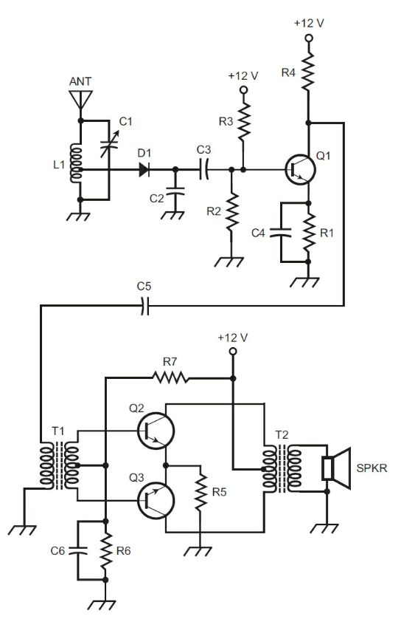

Different devices, when combined, form a system. An amateur radio station is a good example of such a system. It might consist of a transceiver (transmitter/receiver in a single box), an antenna tuner, a computer, an interface unit that goes between the computer and the transceiver, and a speech processor that goes between the microphone and the transceiver.

Foldout pages can be used for showing large diagrams together, without having to separate sections to other pages or force the diagram to a single page where it may be too small to see. In cases where a diagram may be forced across several following pages, an arrow with an “X” is usually included to indicate this to the reader. The page that follows would have an arrow with an “X” pointing to the left to indicate where these two join together. Some circuits need two or more arrows, so we might label them as X, Y, and Z, for example. Then the two “Xs” would connect, the two “Ys” would connect, and the two “Zs” would connect.

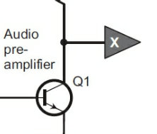

Whenever you draw diagrams of multistage systems, it’s a good idea to add labels to each stage to describe its function.

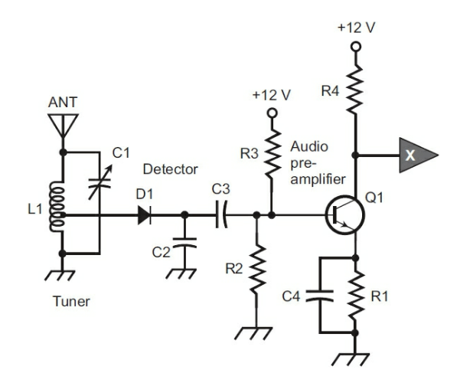

An LC circuit is a type of electrical circuit that uses an inductor and a capacitor. It can create oscillations or alternating currents at a specific frequency. The circuit works by storing and transferring energy between the inductor and the capacitor. It’s commonly used in radios and other electronic devices to tune into different frequencies.

In electronics, bias refers to the steady voltage or current applied to a component to make it work correctly. For example, in a transistor, biasing sets the right operating conditions for the transistor to amplify signals or switch on and off properly. Essentially, bias ensures that electronic components operate within their optimal range.

Impedance is the total opposition to the flow of alternating current (AC) in an electrical circuit. It's like resistance, but for AC circuits. Think of it as the combined effect of friction, bends, and kinks in a hose that slows down the flow of water.

An L network is a simple circuit with an inductor and a capacitor used to match impedance between different parts of a circuit, improving power transfer.

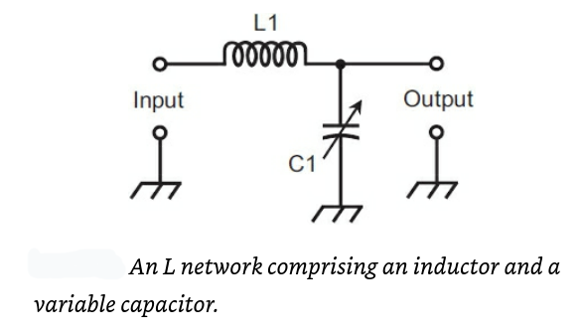

A Pi network is a circuit with two capacitors and one inductor, arranged in a π shape, used for impedance matching and filtering.

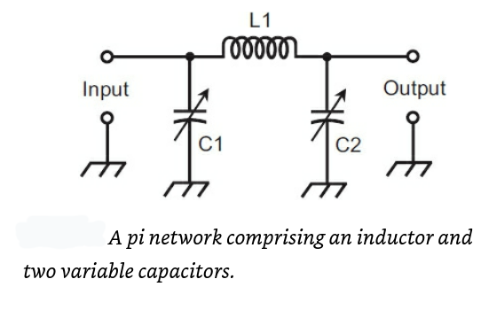

Both the L network and the pi network are commonly used in antenna tuning and matching circuits for radio transmitters at frequencies ranging up to around 150 MHz.

When you follow a pi network with an L network, we get a so-called pi-L network. The advantage of a circuit like that lies in its ability to make radio transmitters work with antennas that would otherwise not accept power very well.

Some circuits can be made more versatile by using variable inductors rather than fixed inductors. One particular type of variable inductor has become popular among radio amateurs. It’s called a roller inductor.

The below diagram shows a slightly complicated device called a code practice oscillator. It is used for learning morse code and features a twin-T oscillator. It has this name due to the T-shaped configurations, including the resistors marked Rx and the capacitors marked Cx (highlighted in the diagram). The twin-T oscillator produces an AF (audio frequency) tone that’s pleasing to the ears, and that also occurs at a predictable and stable pitch (frequency).

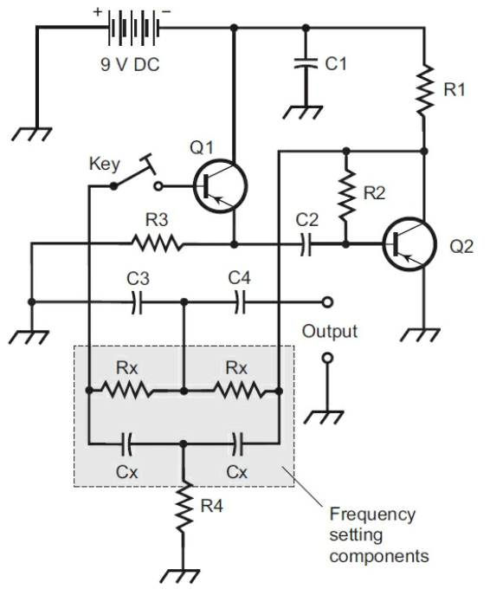

Phase inversion is when a wave is flipped so that its high points become low points and vice versa. This creates a signal that's the opposite of the original, often used in audio and signal processing.

Phase coincidence occurs when two or more waves or signals have their peaks and troughs aligned, meaning they happen at the same time. When this happens, the waves are "in phase" and can combine to create a stronger signal. This concept is important in areas like physics and engineering, where aligning signals is crucial for effective communication and signal processing.

A positive ground system connects the positive terminal of a power source to the chassis or ground, making the negative terminal the live wire. This setup was used in some older vehicles and equipment, but most modern systems now use a negative ground instead.

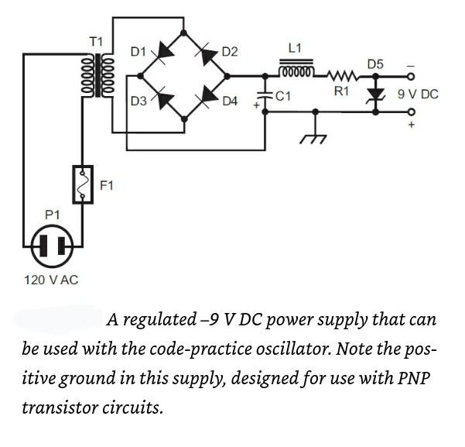

The symbol below is used to show headphones in a circuit.

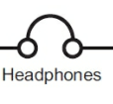

The symbol below is used to show a speaker in a circuit.

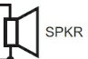

An inductance-capacitance (LC) circuit is an electrical circuit that consists of an inductor and a capacitor. The inductor stores energy in a magnetic field, while the capacitor stores energy in an electric field. When combined, they can create oscillations, where energy continuously flows back and forth between the inductor and capacitor. These circuits are often used in radios, filters, and oscillators to tune to specific frequencies.

A high-pass circuit is an electronic filter that allows high-frequency signals to pass through while blocking or reducing low-frequency signals. It’s often used in audio systems to remove bass (low frequencies) and let treble (high frequencies) come through clearly.

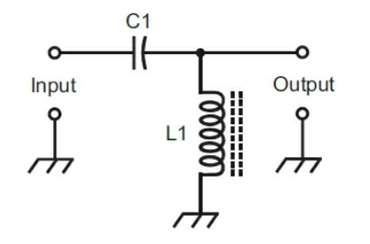

A low-pass filter lets low sounds through while blocking high sounds. It's used to keep bass sounds and reduce treble in audio systems.

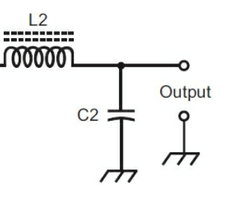

When we follow a high-pass filter with a lowpass filter, and if we choose the cutoff frequencies (or transition points) so that the high-pass filter’s cutoff frequency lies below the lowpass filter’s cutoff frequency, we can get a bandpass filter in which a signal can get through easily only when its frequency lies between the two cutoffs.

You’ll often find repetition of circuit configurations, one after another, in electronic system design. Sometimes you’ll see several identical or similar circuits connected together.

A problem that occurs in one circuit might also occur in any of the others, and you can use the schematic diagram to track down the problem.

Troubleshooting complex systems is simplified by using schematics to break them down hierarchically. Start with complex circuits, then simple circuits, and finally individual components. This systematic approach, guided by schematics, allows for efficient identification and repair of faults, saving time and effort compared to troubleshooting without such documentation. This is often called troubleshooting to the component level.

Without a schematic diagram, even well-equipped technicians struggle to efficiently locate faults in electronic devices. Schematics are crucial for pinpointing problematic sections or components on circuit boards or chassis, as they provide a map of the device's internal structure. This guidance significantly speeds up the troubleshooting process.

Interfacing in electronics refers to the process of connecting different electronic systems, components, or devices so they can communicate and work together effectively. It involves ensuring that the electrical signals, data formats, and protocols are compatible between the interconnected parts.

A breadboard is a reusable platform for prototyping electronic circuits without the need for soldering.

Testing individual electronic components before use can help in preventing frustration later. When you discover a bad component before building, you are able to replace it with a functional component- avoiding the problem of having to locate the issue later on.

Wire wrapping is a technique used in electronics for creating electrical connections between components without soldering.

Jumper wires- also called clip leads or alligator clips- are short electrical wires used to connect components in a circuit, typically on a breadboard or between different parts of a circuit board.

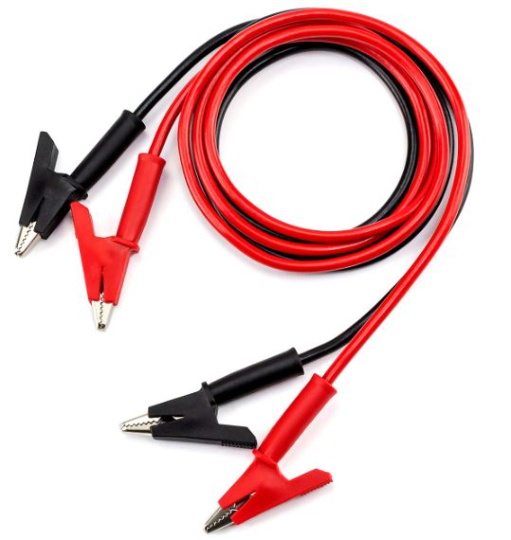

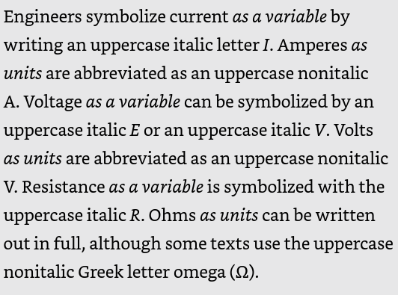

Kirchhoff's Current Law (KCL) is a fundamental principle in electronics stating that the sum of currents entering a junction in a circuit equals the sum of currents leaving it. Simply put, "what goes in must come out." This law reflects the conservation of electric charge and is crucial for analyzing circuits. At any node where wires meet, the total current flowing in balances exactly with the total current flowing out, maintaining a zero net current at the junction. This principle is essential for solving circuit problems and understanding current flow in electrical networks.

In electronics, a branch point is a node where current divides into two or more paths, splitting the circuit into separate branches. It's where the current has multiple flow options, and is crucial for circuit analysis.

Note the use of italics and subscripts for the resistor designators here:

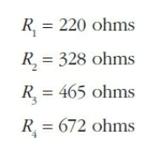

This notation is commonly used for capacitors, inductors, diodes, and other components as well.

A load resistor is a resistor that absorbs excess energy, stabilizes voltage, tests circuits, or terminates transmission lines, ensuring stable circuit operation.

A characteristic curve is a graph showing the relationship between variables of a device or circuit, helping engineers understand behavior, analyze performance, and optimize design.

A logarithmic scale is a way to show big changes in a small space, by using multiplication instead of addition.

Conductance is how easily electricity flows through a material or circuit. It's the opposite of resistance.

Peak Inverse Voltage (PIV): the maximum voltage a diode can handle in reverse without getting damaged.

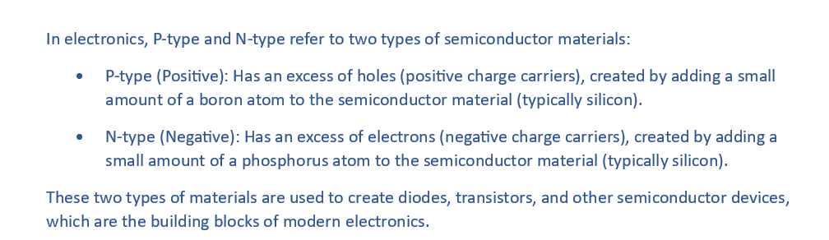

Forward Bias is when a diode is connected in a way that allows it to conduct current freely, like a short circuit. This happens when the positive side (anode) is connected to a positive voltage and the negative side (cathode) is connected to a negative voltage. Forward bias turns the diode ON, allowing electricity to flow easily.

Reverse Bias is when a diode is connected to prevent current flow. The positive side (anode) is connected to a negative voltage and the negative side (cathode) to a positive voltage. This turns the diode OFF, making it non-conductive and blocking electricity from flowing, like an open circuit.

Forward Breakdown Voltage is the minimum voltage required to cause a diode to conduct current when it's forward-biased. Below this voltage, the diode doesn't conduct. Above it, the diode conducts freely.

The Avalanche Effect is when a high voltage causes electrons to multiply and create a surge of current in a semiconductor device. It can be harmful, but is also used in some devices to control voltage and speed. Think of it like a small spark that can ignite a big reaction.

When you connect two or more identical rectifier diodes in series with their polarities in agreement, the forward-breakover voltages add up (give or take a little), so you can get stable and predictable voltage drops that come quite close to whole-number multiples of the forward breakover voltage of a single diode.

Below is the symbol for a circuit breaker.

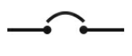

Below is the symbol for a directional coupler.

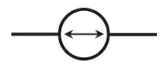

Below is the symbol for a general female contact.

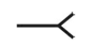

Below is the symbol for a fuse.

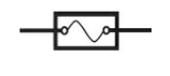

Below is the symbol for a general integrated circuit.

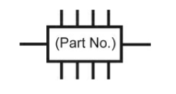

Below is the symbol for an incandescent lamp.

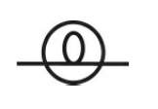

Below is the symbol for a neon lamp.

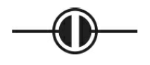

Below is the symbol for a resonator.

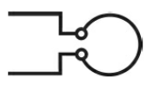

Below is the symbol for a signal generator.

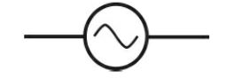

Below is the symbol for a momentary contact switch.

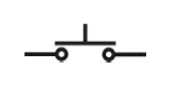

Below is the symbol for a TRIAC. It is a semiconductor device that acts like a switch to control alternating current (AC) power. It can turn AC power on and off, and also adjust the amount of power flowing to a device.

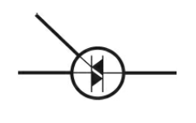

Axial leads are attached to a component at opposite ends, like an axle, and are typically used for through-hole components that are inserted into a PCB. Radial leads, on the other hand, are attached to the same side of the component, like spokes of a wheel, and are used for surface-mount components that are mounted on the surface of a PCB. The main difference is how the leads are arranged and how the component is mounted on the board.

